Splunk SIEM – Dashboards, Reports, and Alerting for SOC Monitoring

Executive Summary
Security Information and Event Management (SIEM) platforms such as Splunk are widely used in enterprise environments to collect, aggregate, and analyse security logs from multiple systems. However, large volumes of log data can quickly overwhelm analysts, making it difficult to identify meaningful security insights.
This exercise focused on improving data analysis and monitoring within Splunk by implementing reports, dashboards, and alerts. These features help security teams organize large datasets, visualize trends, and automatically detect suspicious activity.
The lab demonstrated how SOC analysts can convert raw log data into actionable insights by using Splunk’s search queries, scheduled reports, visualization dashboards, and alerting mechanisms.

Objective
The primary objective of this lab was to understand how Splunk can be used to organize and visualize large volumes of log data to support Security Operations Center (SOC) monitoring and incident detection.
The following tasks were performed:
- Performing log searches in Splunk
- Creating scheduled reports for recurring investigations
- Building dashboards to visualize security data
- Understanding how to configure alerts for suspicious activity

Environment
Component | Description
Platform | Splunk SIEM
Interface | Search & Reporting App
Data Sources | Network server, Web server, VPN server
Visualization | Dashboards and Charts
Detection Mechanism | Scheduled Alerts

Investigation Process

1. Exploring Log Data in Splunk
After logging into the Splunk instance, the Search & Reporting interface was used to analyze the available data.
A broad search was executed using:

index=*

This query displayed all indexed logs across the environment.
The search results returned over 35,000 events, demonstrating how quickly large log datasets can become overwhelming when viewed in raw format.
In real-world SOC environments, analysts avoid running searches across “All Time” because this can place heavy load on the Splunk search head.
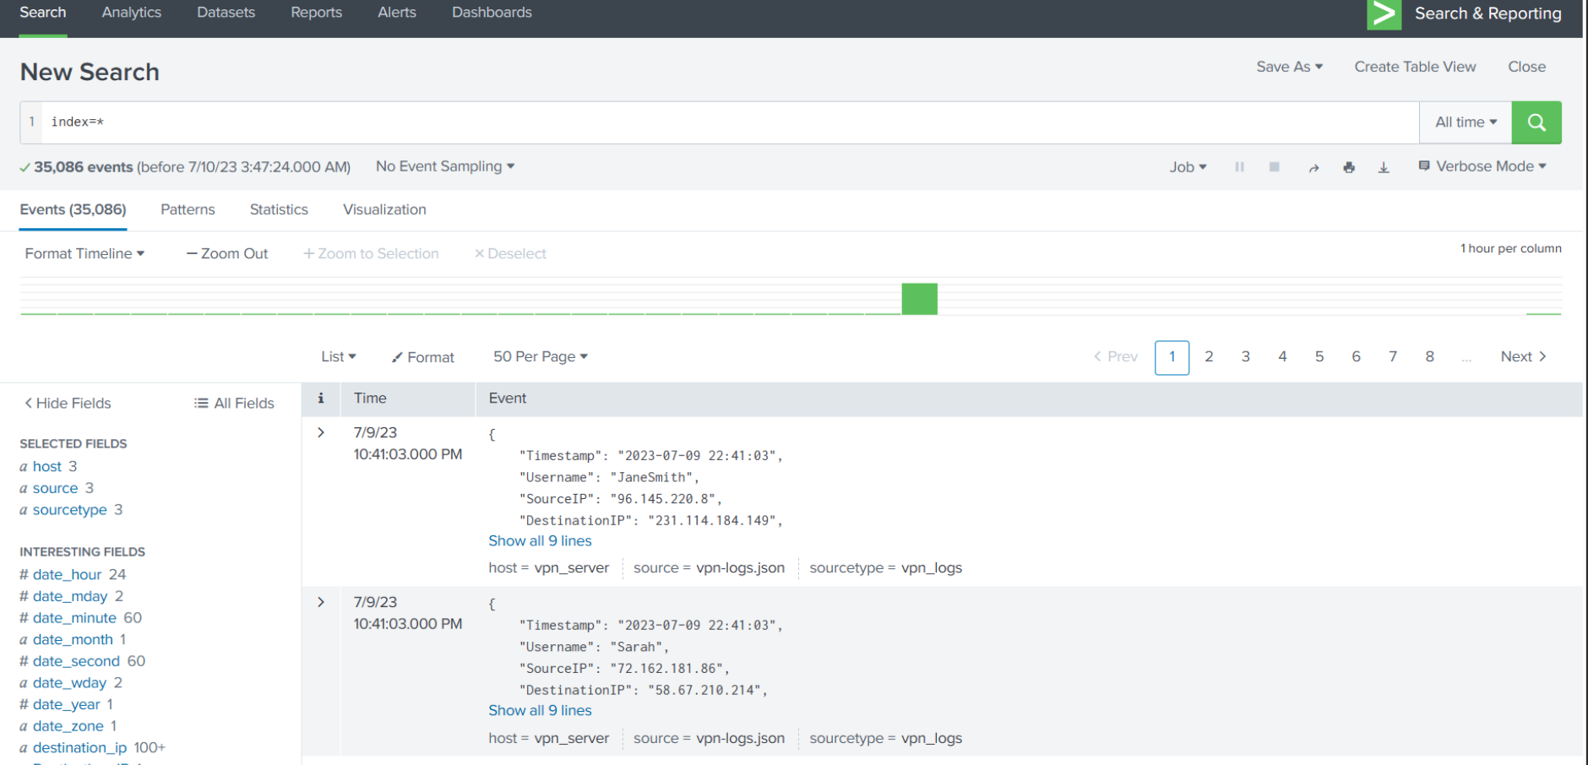

2. Identifying Active Log Sources
Splunk automatically extracts fields from ingested logs.
One useful field is host, which identifies systems sending logs to Splunk.
The analysis revealed three primary log sources:
Host | Description
network-server | Network infrastructure logs
web-server | Web application activity
vpn_server | VPN authentication activity

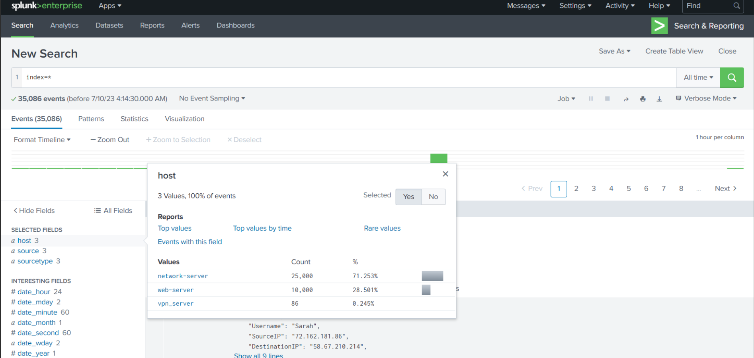

3. Querying VPN Login Activity
To analyse VPN user activity, the following query was executed:

host=vpn_server | stats count by Username

This query counted the number of login events associated with each user.
The results showed that:
- Sarah logged in the most frequently
- Emma logged in the least
This type of analysis is commonly used in SOC environments to identify unusual login patterns.
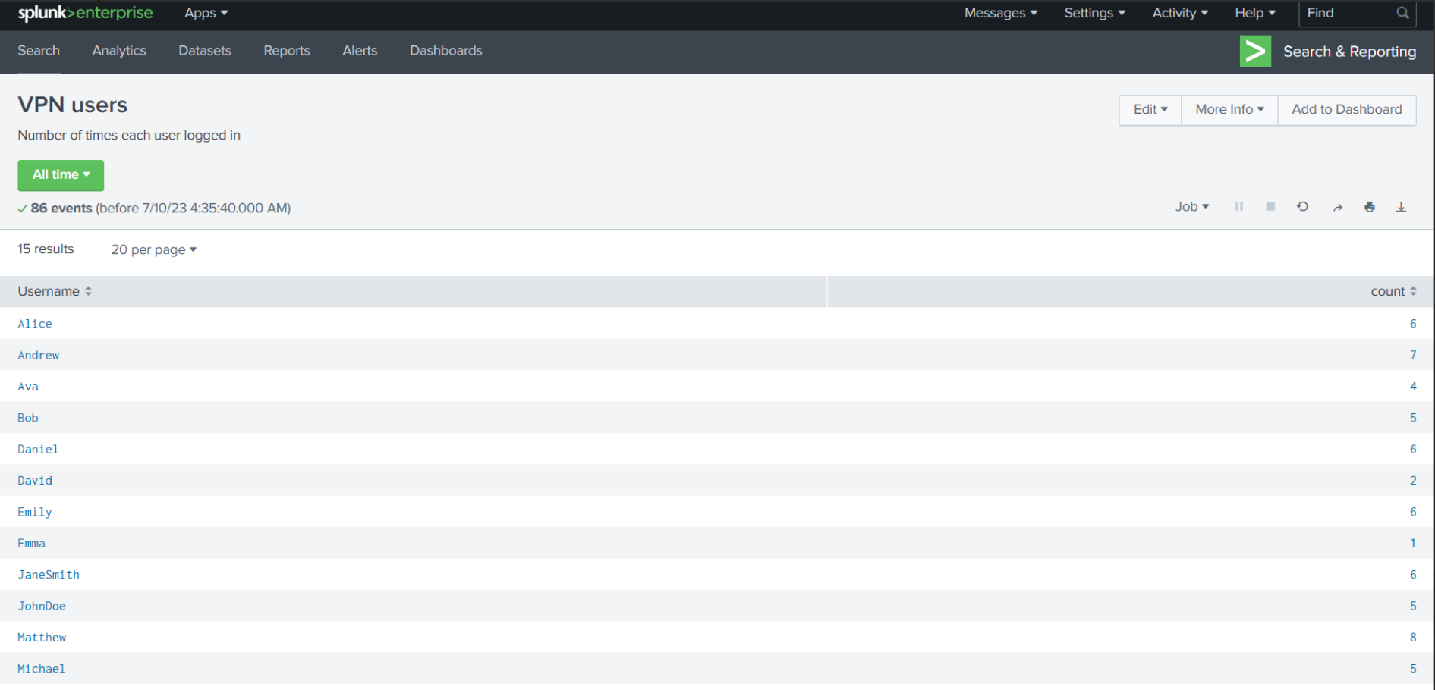

4. Creating Scheduled Reports
SOC analysts often need to run the same searches repeatedly.
Instead of executing them manually, Splunk allows analysts to save searches as reports.
Reports provide several benefits:
- Automated execution of recurring searches
- Reduced load on the Splunk search head
- Easy access to previously generated results
To create a report:
- Run a search query
- Select Save As
- Choose Report
- Configure title and permissions
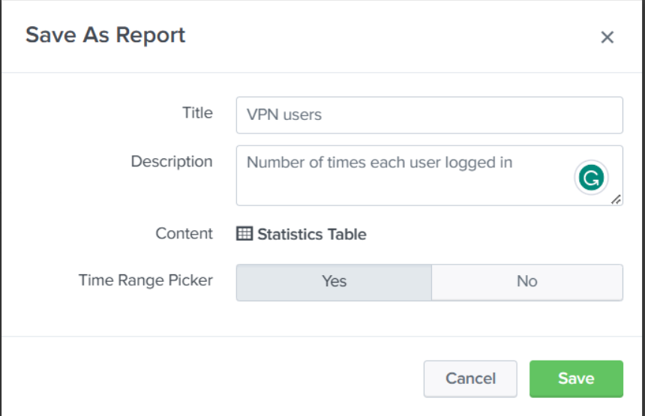

Reports can also be scheduled to run at regular intervals, such as every shift in a SOC environment.

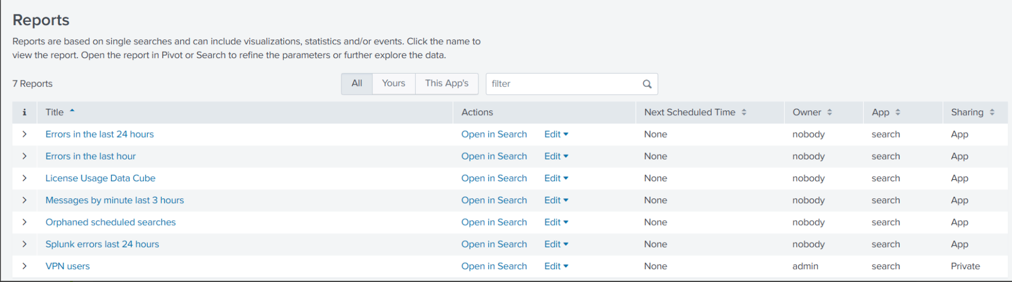
5. Creating Security Dashboards
While reports provide structured data, dashboards allow analysts to visualize security metrics.
Dashboards help SOC teams quickly understand system activity without manually reviewing raw logs.
To create a dashboard:
- Navigate to the Dashboards tab
- Select Create Dashboard
- Define permissions and dashboard name
- Add panels containing reports
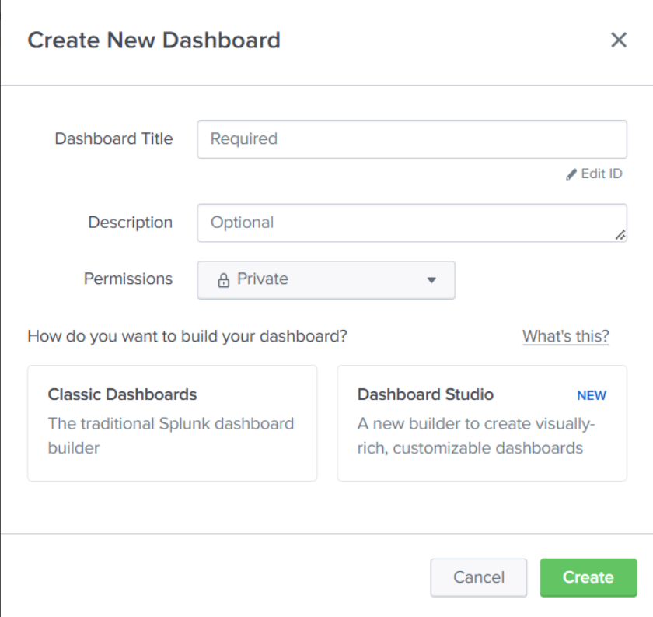

A column chart visualization was applied to display VPN login activity.
This made it easy to quickly identify which users had the highest number of login attempts.
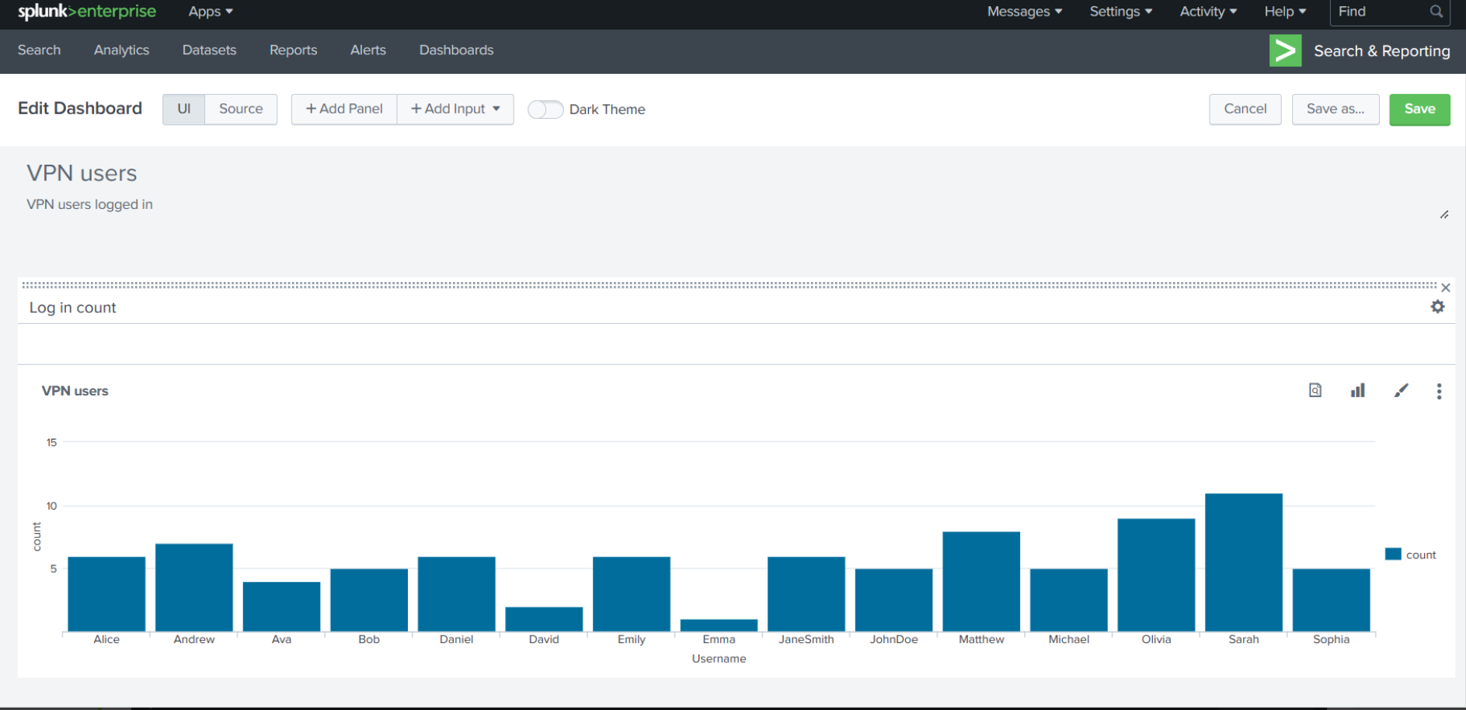

Dashboards are often used by:
- SOC analysts for monitoring activity
- Security teams for incident analysis
- Management for security posture reporting

6. Understanding Splunk Alerts
While dashboards and reports provide visibility, SOC teams also require real-time notifications when suspicious activity occurs.
Splunk alerts allow analysts to automatically detect events based on defined conditions.
Example alert configuration:
Objective: Detect abnormal login activity for user Sarah.
Query example:

Username=Sarah

Alert configuration included:
Setting | Value
Alert Type | Scheduled
Condition | Login count greater than 5
Frequency | Every 1 hour
Action | Send email notification
If the threshold is exceeded, Splunk automatically sends an email to the SOC team.
This mechanism helps detect potential brute-force login attempts or compromised accounts.

Timeline of Activity
Time | Event
Login to Splunk | Accessed Search & Reporting interface
Data exploration | Ran index=* search
Host analysis | Identified active log sources
Query execution | Investigated VPN login activity
Report creation | Saved search as scheduled report
Dashboard creation | Built visualization panel
Alert configuration | Defined threshold-based alert

Conclusion
This exercise demonstrated how Splunk SIEM can transform raw log data into structured insights through reports, dashboards, and alerts.
Key capabilities demonstrated included:
- Log data exploration
- Security event aggregation
- Scheduled reporting
- Data visualization
- Alert configuration
These features are essential for SOC teams because they allow analysts to monitor large volumes of data efficiently and detect potential threats in real time.

Key Skills Demonstrated
- Splunk SIEM administration
- Log search and analysis
- Security data visualization
- SOC monitoring workflows
- Alert threshold configuration
- Dashboard development

Recommendations
To further improve the monitoring environment:
- Implement correlation rules for suspicious behaviour
- Integrate additional log sources such as firewalls and IDS
- Create incident response dashboards
- Develop alerts for brute-force login detection
These improvements would enhance the organization's ability to detect and respond to security incidents.

